**Property Indication**

**Property Information:**

|  |  |
| --- | --- |
| **Properties Address:** | No. 84, St. F1, Sangkat Bak Kheng, Khan Chroy Chongva, Phnom Penh, Cambodia. |
| **Property Type** | Link House 1 |
| **Land Size** | 84.80m2  (5.3m * 16m) |
| **Building Size:** | 84.80m2  (5.3m * 8m * 2floors) |
| **Title Deed No:**  **SPA** | 41277  USD54,055.00 On Date: 10 April 2016 |

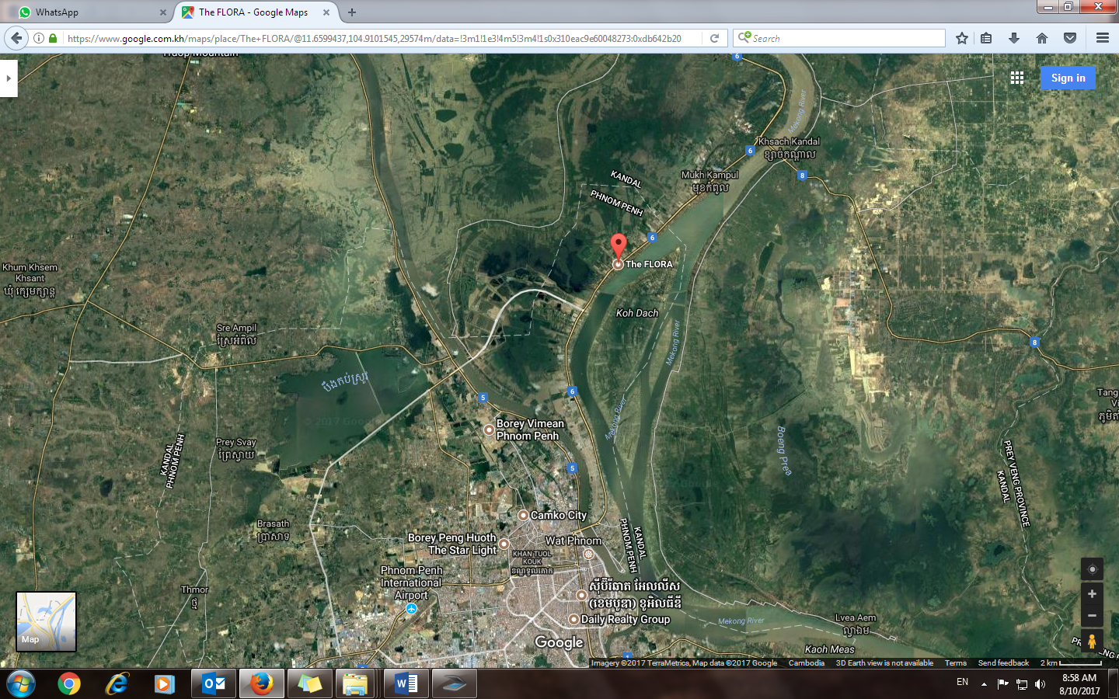

**Borey the Flora**

Chroy Changva Bridge

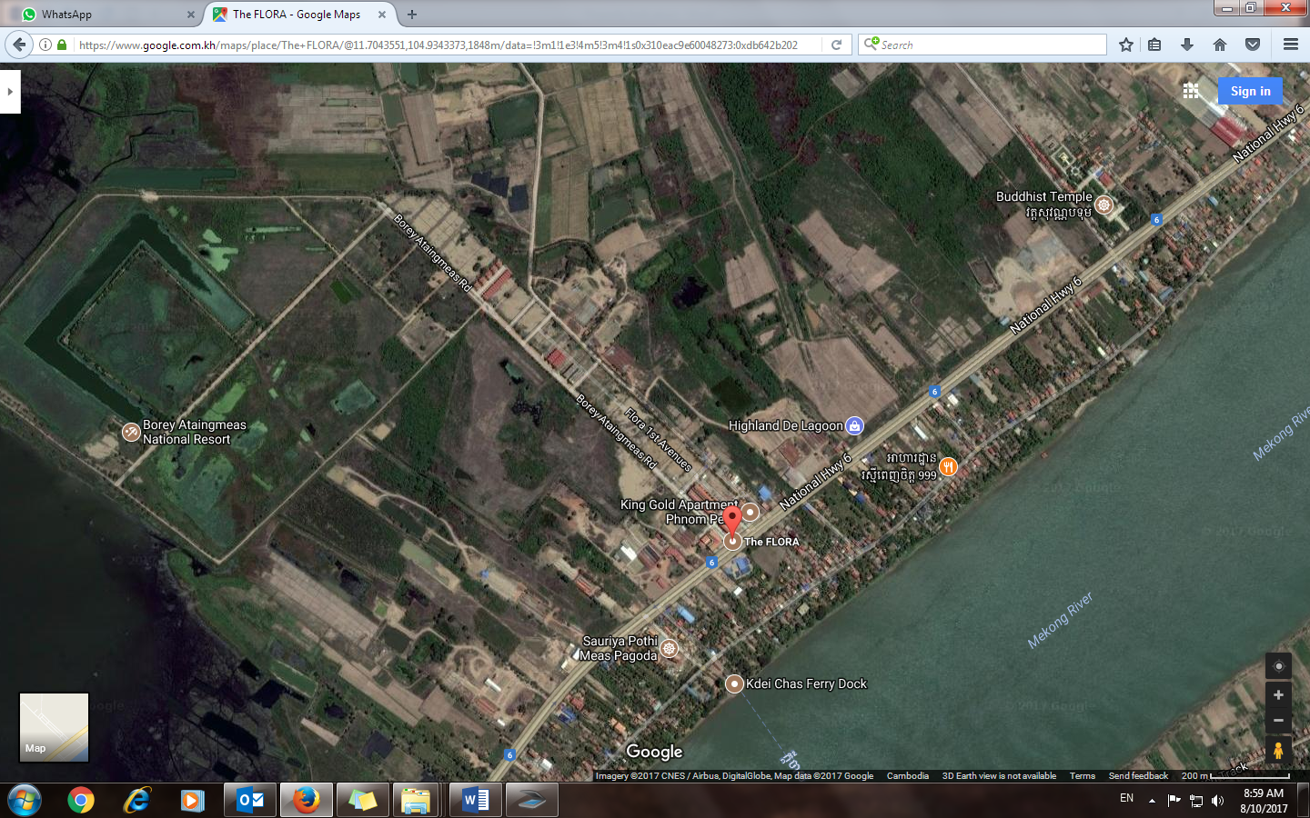

**Borey the Flora**

